CNN-Driven OCR: A Model for Accurate Recognition of English Handwritten Notes

Shrouk Mohsen Ibrahim Elhosiny.   
Information Systems Department. Faculty of Computer & Information Sciences, Ain Shams University.Cairo, Egypt.  
20201700401@cis.asu.edu.eg

Habiba mohamed Adel Abdelaziz.   
Information Systems Department. Faculty of Computer & Information Sciences, Ain Shams University.Cairo, Egypt.  
20201701191@cis.asu.edu.eg

Fatma-Elzahraa Mansour Ibrahim .   
Information Systems Department. Faculty of Computer & Information Sciences, Ain Shams University.Cairo, Egypt.  
20201700564@cis.asu.edu.eg

Mayar Mohsen Fahiem Mohammed .   
Information Systems Department. Faculty of Computer & Information Sciences, Ain Shams University.Cairo, Egypt.  
20201700875@cis.asu.edu.eg

Mohamed Khaled Hammed Mohamed.   
Information Systems Department. Faculty of Computer & Information Sciences, Ain Shams University.Cairo, Egypt.  
20201700687@cis.asu.edu.eg

Youssef Usama Morsy   
Information Systems Department. Faculty of Computer & Information Sciences, Ain Shams University.Cairo, Egypt.  
20201701001@cis.asu.edu.eg

*Abstract*— Handwriting recognition is widely used in the recognition, processing, and management of various information to improve efficiency in numerous industries such as banking, healthcare, and education. It enables the digitization of handwritten documents, making data entry and retrieval faster and more accurate. Convolutional neural networks (CNNs) help eliminate the need for manual extraction of feature sets, significantly enhancing the efficiency and accuracy of recognition tasks. In this paper, a generalization-enhanced network recognition model is proposed using an improved lightweight convolutional neural network architecture. This model leverages a novel method to adapt word recognition through the concept of pre-recognition segmentation, which ensures that individual components of handwritten text are accurately identified before full recognition is attempted.

Moreover, the model's generalization capability is enhanced by diversifying and pre-processing the dataset. As a result, the recognition system can accurately interpret various types of handwriting styles and recognize scenes with different levels of complexity. The experimental results demonstrate that the proposed model achieves an impressive accuracy of 95% on the test set. When compared with other classical network models, our model not only shows superior recognition accuracy but also exhibits faster convergence rates and better generalization ability, making it highly suitable for real-world applications. This advancement in handwriting recognition technology paves the way for more efficient and reliable systems that can be integrated into various applications, ultimately leading to increased productivity and reduced error rates.

Keywords— neural network, LeNet-5, Histogram segmentation

# Introduction

Human society has always been improving material well-being, pursuing more advanced technology, and an easy, better way of living. The development of modern technology has greatly improved productivity and quality of human life, allowing people to break from heavy labor. However, regular machines could only replace people's work in the physical world but don't help them in solving mental problems, so artificial intelligence (AI) was derived from computer science. AI was created to replace human mind when dealing with large amounts of information. Information input is particularly important in artificial intelligence, where it directly determines the ability, efficiency, and even accuracy of the system to receive information. Pattern recognition is the ideal input state. It allows intelligent systems to learn without the process of manual feature extraction. With the rise of the idea of "unmanned systems", pattern recognition has quickly become a popular topic. In the past few years, machine learning tasks, such as object detection, translation, handwriting recognition, and speech recognition, have heavily relied on the manual extracting of characteristics and feature sets. This phenomenon changed when various deep learning methods such as Convolutional Neural Networks (CNN): a deep structural network of feedforward neural networks with convolutional computation. Convolutional neural networks are capable of both supervised and unsupervised learning

Handwriting digits and character recognitions have become increasingly important in today's digitized world due to their practical applications in various day to day activities. It can be proven by the fact that in recent years, different recognition systems have been developed or proposed to be used indifferent fields where high classification efficiency is needed. Systems that are used to recognize Handwriting letters, characters, and digits help people to solve more complex tasks that otherwise would be time-consuming and costly. The handwriting recognition systems can be inspired by biological neural networks, which allow humans and animals to learn and model non-linear and complex relationships .

The development of handwriting recognition systems has been inspired by biological neural networks, which enable humans and animals to learn and model complex, non-linear relationships. This concept is mirrored in artificial neural networks (ANNs), specifically convolutional neural networks (CNNs), which have proven highly effective in image and pattern recognition tasks.

CNNs are a type of deep learning model particularly well-suited for handwriting recognition due to their ability to automatically and adaptively learn spatial hierarchies of features from input images. This eliminates the need for manual feature extraction, enhancing the accuracy and efficiency of recognition systems. By leveraging the architecture of CNNs, modern handwriting recognition models can accurately identify and classify handwritten digits, letters, and characters, leading to significant improvements in automated processing systems and overall productivity in various applications.

# Related Work

There has been a lot of work on handwritten English character and digit recognition as a recent topic of study. To tackle this challenge, a variety of innovative strategies have been proposed.

* A Multi-Layer Perceptron has been proposed to recognize handwritten English characters in a paper [1]. The paper claims to achieve 94% accuracy with very little training time.
* the NIST SD19 standard dataset, Neves et al. has constructed an offline handwritten character recognition system based on Support Vector Machine (SVM) that outperformed the multi-layer perceptron classifier [2].
* Mahmoud M. Abu Ghosh and Ashraf Y. Maghari compared DNN , CNN and DBN to determine the best algorithm for recognition by considering accuracy, performance and execution time .After experimentations the results of accuracy and performance ,CNN and DNN algorithms were almost equal in terms of accuracy and DNN algorithm was better than CNN and DBN in terms of execution time [3].
* Vincent Neiger gave a detailed introductory investigation on performance in various aspects and a compared error rates on K-Nearest Neighbor , Random Forests and Support Vector Machines classifiers . 81% was concluded as the best error rate with SVM classifier [4-5]
* Handwritten Recognition of MNIST dataset Using Deep Learning state-of-the-art Artificial Neural Network and CNN. The paper claims to achieve 80% accuracy [6].
* Handwritten Recognition using Convolution neural network that is revised from LenNet-5 , is used for handwritten letter recognition. This study uses the EMINST dataset to train the model, and the final recognition rate is about93.44%[7-8].
* Handwriting character recognition is one of the research fields in computer vision, artificial intelligence, and pattern recognition [9-14]. A computer application that performs handwriting recognition can be argued to have the ability to acquire and detecting characters in pictures, paper documents, and other sources and convert them into electronic format or machine-encoded form. The system may obtain Handwriting sources from a piece of paper through optical scanning or intelligent word recognition.

.

# System Architecture

We Will describe a comprehensive pipeline for processing and recognizing handwritten text from images using a series of computer vision and machine learning techniques. The pipeline involves several stages: preprocessing the input image, segmenting the image into lines of text, further segmenting those lines into words and characters, and finally recognizing each character using a pre-trained model.

Pipeline Overview:

Image Preprocessing: Converts the input image to grayscale, applies adaptive thresholding to enhance text regions, and performs morphological operations to reduce noise and improve character shapes.

Line Segmentation: Utilizes horizontal histograms to identify and segment individual lines of text within the preprocessed image.

Word Segmentation: Uses Optical Character Recognition (OCR) data to locate and segment words within each line of text.

Character Segmentation: Employs vertical histograms and morphological operations to isolate individual characters from each word.

Character Recognition: Applies a machine learning model to predict and label each segmented character, reconstructing the original text content.

# Results

The character segmentation and recognition pipeline we implemented demonstrates robust performance in processing handwritten text. The preprocessing steps, including grayscale conversion, adaptive thresholding, and morphological operations, effectively enhance the text regions, making them suitable for subsequent segmentation. The line, word, and character segmentation functions accurately isolate individual text components, enabling precise character recognition.

|  |  |
| --- | --- |
| Technique | Accuracy |
| LeNet-5 | 95% |
| MLP-SVM | 90% |
| Decision tree | 87% |

The dataset utilized for training and evaluating our handwriting recognition model is a comprehensive collection of images comprising both characters and numbers. Each class in this dataset, whether it represents a letter (A-Z) or a number (0-9), contains a total of 1500 images, ensuring a balanced representation across all classes.

Dataset Composition:

Classes: The dataset includes a total of 36 classes (26 alphabet characters + 10 digits).

Image Count per Class: Each class contains 1500 images, amounting to a total of 54,000 images in the entire dataset.

Image Dimensions: All images are standardized to a fixed size of 28x28 pixels to maintain uniformity and facilitate consistent input for the model.

Image Format: The images are in grayscale format, reducing complexity and focusing on the essential features for recognition.

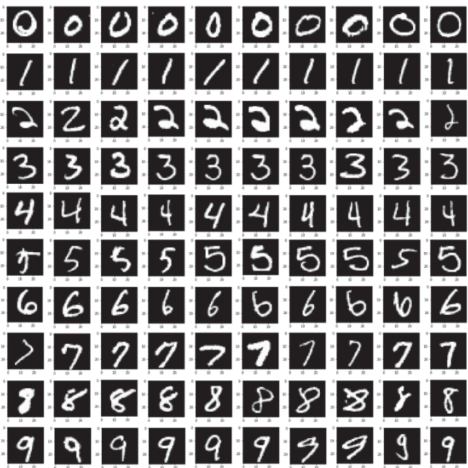

# Conclusion

In conclusion, our character segmentation and recognition pipeline has proven to be an effective and robust solution for recognizing handwritten text. By focusing on the segmentation and recognition of individual characters rather than whole words or sentences, we have built a flexible system capable of accurately interpreting a wide variety of handwriting styles and formats.

By recognizing characters individually, our system can accurately process any word, phrase, or shortcut, making it a powerful tool for handwriting recognition. This character-based methodology not only enhances accuracy but also ensures the flexibility and adaptability needed for a wide range of practical applications.

Overall, our project demonstrates that a well-structured pipeline for character segmentation and recognition can achieve high performance and flexibility, providing a reliable solution for various handwriting recognition tasks.

# References

[1] P. Pal and D. Singh, "Handwritten English Character Recognition using Neural Network," International Journal of Computer Science and Communication, vol. 1, no. 2, pp. 141-144, 2010.

[2R. F. P. Neves, A. N. G. L. Filho, C. A. B. Mello, and C. Zanchettin, "A SVM based off-line Handwritten Digit Recognizer," in International Conference on Systems, Man, and Cybernetics, Brazil, Oct. 9-12, 2011, pp. 510-515.

[3] M. Abu Ghosh and A. Maghari, "A Comparative Study on Handwriting Digit Recognition Using Neural Networks," in Proceedings of the 2017 International Conference on Promising Electronic Technologies (ICPET), Deir El-Balah, Palestine, 2017, pp. 77-81, Doi: 10.1109/ICPET.2017.20.

[4] V. Neiger, "Handwritten digits recognition using OpenCV," 2015.

[5] A. Azar, A. Khamis, N. A. Kamal, and B. Galli, "Machine Learning Techniques for Handwritten Digit Recognition," in Lecture Notes in Networks and Systems, vol. 739, 2020, Doi: 10.1007/978-3-030-44289-7_739.

[6] A. Harikrishnan, S. Sethi, and R. Pandey, "Handwritten digit recognition with feed-forward multi-layer perceptron and convolutional neural network architectures," in 2020 2nd International Conference on Innovative Mechanisms for Industry Applications (ICIMIA), Bangalore, India, Mar. 2020, pp. 398-402, doi:10.1109/ICIMIA48430.2020.9074873.

[7] Y. Lecun, L. Bottou, Y. Bengio, and P. Haffner, "Gradient-based learning applied to document recognition," Proceedings of the IEEE, vol. 86, no. 11, pp. 2278-2324, Nov. 1998, Doi: 10.1109/5.726791.

[8] X. Gao, "An improved method of handwritten character recognition based on CNN," Innovation in Science and Technology, 2017.

[9] C. C. Aggarwal, Neural Networks and Deep Learning: A Textbook, Basingstoke, England: Springer, 2018.

[10] V. E. Balas, S. S. Roy, D. Sharma, and P. Samui, Handbook of Deep Learning Applications, Basingstoke, England: Springer, 2019.

[11] A. Boukharouba and A. Bennia, "Novel feature extraction technique for the recognition of handwritten digits," Applied Computing and Informatics, vol. 13, no. 1, pp. 19-26, 2017, Doi: 10.1016/j.aci.2015.05.001.

[12] M. K. Buckland, Emanuel Goldberg and His Knowledge Machine: Information, Invention, and Political Forces, Santa Barbara, CA: Greenwood Publishing Group, 2006.

[13] L. Chen, S. Wang, W. Fan, J. Sun, and S. Naoi, "Beyond human recognition: A CNN-based framework for handwritten character recognition," in 2015 3rd IAPR Asian Conference on Pattern Recognition (ACPR), Kuala Lumpur, Malaysia, 2015, pp. 695-699, Doi: 10.1109/ACPR.2015.7486592.

[14S. Ding, H. Zhao, Y. Zhang, X. Xu, and R. Nie, "Extreme learning machine: algorithm, theory and applications," Artificial Intelligence Review, vol. 44, no. 1, pp. 103-115, 2015, Doi: 10.1007/s10462-014-9428-7.